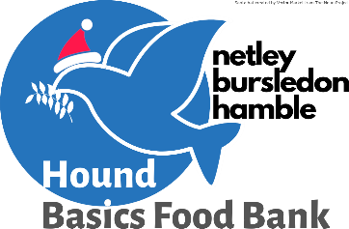
Core Food List

Custard/Rice Pudding  Chocolate bars / sweets  Small packs tea bags  Angel delight  Quick rice  Tinned meat meals  Quick pasta  Cook in sauces non- tomato  Baby wipes  Toothpaste/Toothbrushes  Kid’s healthy snacks  Stock cubes/Gravy granules  Steamed puddings  Hot chocolate/Horlicks  Quick porridge  Lasagne Sheets | Cold meat e.g. corned beef  Tinned Chicken Meat Meals  Coffee (small)  Tinned Spaghetti  Small jelly/fruit pots  Hotdogs  Crisps  Jellies  Savoury Crackers  Tinned Fruit  Vegetarian meal options e.g. macaroni cheese  Cereal  Tinned peas or carrots  Tuna/other fish  Fruit juice (cartons)  Toilet rolls  Soap bars | Tinned sweet corn  Antiseptic wipes  Tomato sauce/brown sauce  Shampoo  Shower gel (unisex)  Jam/peanut butter/marmite  Fray Bentos pies  Family size swiss roll (Molly’s)  Cereal bars  Packet sauces  Liquid soap  Evaporated Milk  Pot Noodles/quick noodles  Baked beans  Tinned soup (not tomato)  Soft drinks/squash  Biscuits  Cuppa soup
Things we already have enough of:-
Gluten free items  Washing up liquid  Laundry powder/liquid  Sugar  Cook in sauces (tomato)  Tomato Soup | UHT Milk  Pasta / Spaghetti  Tinned Tomatoes  Tinned Beans and Pulses  Rice  Tinned potatoes/mash | Feminine Hygiene products  Nappies (all sizes)  Baby wash  Porridge  Dog Food/Cat Food

