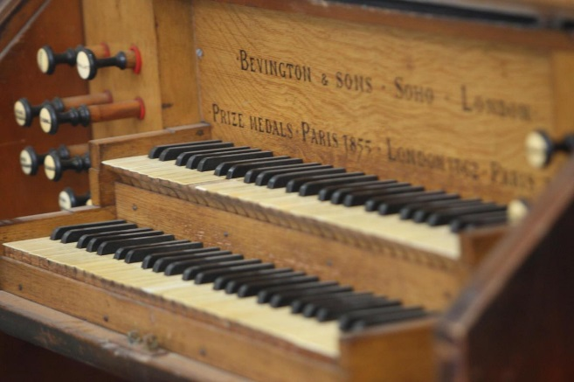

**Experience the sound of**

**The Chapel Organ**

Visit the exhibition and enjoy listening to the beautiful acoustics of the Chapel organ. Local organist John will be volunteering his time to play a few of his favourite pieces.

Friday 14 June – 11.00am

Friday 28 June – 2.30pm

Friday 5 July – 11.00am

Friday 19 July – 11.00am

Friday 2 August – 2.30pm

Friday 16 August – 11.00am