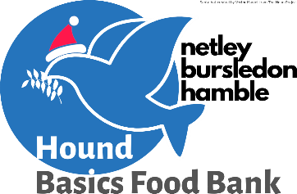
Noëlvember
Reverse
Advent Calendar
Hound Basics Food Bank
Address: 30 Queens View, Netley Abbey, SO31 5EA
Telephone: 07485 007800
Email: houndbasics@netleycf.org.uk
Facebook: https://www.facebook.com/houndbasics
1  Tinned Fruit | 2  Custard | 3  Coffee | 4  Shower Gel | 5  Cereal Bars | 6  Baked Beans
7  Something Christmassy! | 8  Crisps | 9  Fruit Squash | 10  Toothpaste | 11  Tinned Sweetcorn | 12  Tinned Spaghetti
13  Tinned Cold Meat | 14  Biscuits | 15  Something Christmassy! | 16  Rice Pudding | 17  Tea | 18  Cereal
19  Jam/Peanut Butter | 20  Tinned Meat Meal | 21  Dessert {Angel Delight, Jelly, Steamed Pudding) | 22  Baked Beans | 23  Red or Brown Sauce | 24  Something Christmassy!

